Sample media release
Attention-grabbing headline

Release details

Newsworthy first paragraph

Direct quote within the first 3 paragraphs

Indicate the final page of the release

Follow with contact details

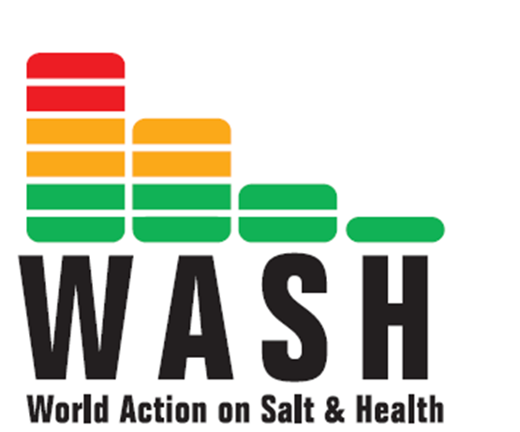
Embargo date
Attention grabbing headline

Embargoed – not for publication before

New Study Reveals Huge Differences in Salt Levels in the Same Iconic Food Brands in Different Countries
Call to action

World Action on Salt and Health Calls for Immediate Action
The big news!
A NEW 2014 international survey by World Action on Salt and Health (WASH) [1] reveals that people in certain countries are still being fed double the amount of salt by popular brands as other countries - reaffirming the chaotic approach being taken by world renowned iconic brands in terms of product formulation and their contribution to the escalating global problem of strokes, heart attacks and heart failure.
Furthermore, not one product surveyed had consistency in its salt content, with huge differences from one country to another. WASH calls ALL food manufacturers to reduce the salt contents of their products in line with the global target to reduce salt intake [2].
Key findings of the new research/ survey

Key findings:
- A KFC Original Fillet Burger in the Middle East contains 3.5g of salt per burger, THREE TIMES as much as the same product sold in Malaysia, which has 1.05g of salt per burger.
- A Burger King Bacon Double Cheeseburger bought in Canada contains 2.85g of salt per burger, while one bought in the New Zealand contains much less salt at 1.92g of salt per burger.
- Nestlé Fitness cereal has 2g of salt per 100g in Russia, while consumers in Chile can eat the same product with less than a HALF of the salt at 0.72 of salt per 100g.
- Kellogg's Cornflakes sold in Venezuela contains 1.90g of salt per 100g compared to the same cereal sold in the UK at 1.25g of salt per 100g; a difference of more salt than a standard packet of ready salted crisps [3].
Direct quote on the research/ survey
This survey has revealed that differences in global taste preferences cannot be blamed for the difference in salt content, as no one country consistently has the saltiest foods. For example, the USA has the MOST salty Kellogg’s Special K, but the LEAST salty Kellogg’s All Bran.
“Manufacturers are clearly able to make products with less salt, but deliberately choose not to, despite salt damaging their customer’s health. This study also highlights a lack of consistent nutrition labelling and portion size across the world which is adding to consumer confusion, as people cannot choose the less salty options, even if they want to. Consistent front of pack nutrient labelling should be provided on ALL products to allow consumers to make better-informed choices” says Clare Farrand, International Programme Lead at WASH.
The good news (if there is any)
Encouragingly there has been a positive change over time with some products having a gradual reduction in salt content since the 2006 WASH survey [4], but still there is a clear lack of consistency about this, for example:
- Kellogg’s Cornflakes in Denmark and Belgium has come down from 2.38g salt per 100g in 2006 to 1.30 salt per 100g in 2014, a reduction of almost half the salt. This is likely due to these cornflakes being manufactured in the UK, where salt targets have been set, and sold in Europe. The fact that they are acceptable for consumers across Europe further highlights, quite clearly, that reductions in salt contents are not noticed by the population and can easily therefore be achieved across the world.
- Subway’s Club 6-inch sandwich has come down in all countries in the survey, the biggest reduction seen in the UK, from 3g salt to 1.7g salt per portion i.e. 43% less salt.
- The salt content of the KFC Twister has come down in all the countries since 2006. For example, in Canada, the salt content of a Twister has fallen from 3.83g to 2.3g salt per portion, 1.5g less hidden salt.
More still needs to be done

However, disappointingly, the salt content of some products has stayed the same in some countries, despite reductions in others, for example - Kellogg’s All Bran cereal in the US and Australia has stayed at 0.65g salt per 100g and 0.95g salt per 100g respectively. In Canada a McDonald’s Big Mac still contains 2.55g salt per portion [4].

More alarmingly some products contain more salt now than they did in 2006. For example, the salt content of McDonald’s Big Mac has gone up in Malaysia, Singapore and Portugal since 2006 [5]. In the UK, the salt content of the Burger King Bacon Double Cheeseburger has increased on average since 2006, from 2.2g per portion to 2.64g per portion- an increase of 20% despite the call to reduce population level salt intake.

“The UK is leading the way in salt reduction, and has set salt targets for over 80 categories of food, however this survey shows that more still needs to be done. It is also clear that greater focus needs to be put on the out of home food sector.” says Clare Farrand “Salt should be going down, not up. This is a major problem, especially with so many people grabbing food on the go.”
Direct quote (why this is so important)
Professor Graham MacGregor, WASH Chairman and Professor of Cardiovascular Medicine at the Wolfson Institute, Queen Mary University of London says, “Reducing salt is the most cost-effective measure that we know to reduce the number of people suffering and dying from strokes, heart attacks and heart failure.
Contact details for media enquiries
“At the World Health Assembly in May 2013 it was unanimously agreed that all countries should reduce their daily salt intake by 30% towards a target of up to 5g per day, by 2025. Our study has shown that many global food manufacturers are not doing enough to help achieve this target, which is completely unacceptable. Indeed this survey reveals a chaotic approach by these world renowned iconic brands and immediate action is required now. Salt should be reduced in all their products to the lowest level in all countries, and further if we are really going to tackle the huge and burdening problem of strokes, heart attacks and heart failure. These companies need to take a much greater corporate and ethical responsibility for what they are doing to their customers!”
Direct the reader to further information

Notes to editors:
National PR - David Clarke: david@rock-pr.com M: 07773 225516
Website www.worldactiononsalt.com
Tweet https://twitter.com/washsalt #LessSalt
Include full details of the research/ survey

[1] Survey details
- Salt per portion and per 100g information was collected from manufacturers' own websites from August 2014.
- Data table sorted by highest salt per suggested portion size (g) in 2014.
- Where portion sizes vary for cereals (Kellogg’s and Nestle), we have used 100g salt for comparison.
- Some cereal values include additional milk.
- Included are the products and equivalent products within countries for which we could locate information via websites.
- Products translated from native language to English.

Criteria for selection
- must operate within at least 3 regions (for ease of analysis/accessibility of information)
- must have at least one widely consumed product
- must have at least one product/product equivalent that is comparable across countries
- must have nutritional information available on website/customer helpline
- local variations are avoided where possible for international relevance

[2] World Health Organisation Guideline: Sodium intake for adults and children http://www.who.int/nutrition/publications/guidelines/sodium_intake_printversion.pdf

[3] Ready Salted Walkers packet of crisps (32g) contains 0.45g of salt sold in the UK

[4] Products in the survey have been surveyed by WASH in 2006 for launch of WASH and again in 2009 - http://www.worldactiononsalt.com/less/surveys/2009/international/index.html

[5] Big Mac in Singapore has gone up since 2006 from 2.20g to 2.68g salt per portion.
Big Mac in Malaysia has gone up since 2006 from 1.83g to 2.70g salt per portion.
Big Mac in Portugal has gone up since 2006 from 1.25g to 2.30g salt per portion.

Portion size may vary

